Contact: Bob O’Donnell
TECHnalysis Research, LLC
Phone (650) 224-2355
bob@technalysisresearch.com

Press Release

Worldwide Device Usage Study Highlights Major Shifts in Consumer Behaviors with Smartphones, Tablets, PCs and TVs

PCs and Smartphones Top Usage, but Dramatic Demographic Differences Reveal Digital Age Gap
Foster City, CA, August 27, 2014: Think people have stopped using PCs in favor of smartphones? An exciting new study from TECHnalysis Research, LLC throws cold water on that and many other commonly held assumptions about how consumers are using their key devices—PCs, tablets, smartphones and TVs—that increasingly sit at the center of their lives. In fact, among many other interesting data points, the study showed consumers around the world are using these devices approximately 9.4 hours per day, on average, and just over 40% of that is actually spent using more than one device at a time.
The report is based on a comprehensive online survey of 2,574 consumers, aged 18-75+, across the US, UK, Brazil and China, fielded in July and August, that looked at what types of activities consumers spend their time on and how those activities are spread across the devices they own. Among the key findings of the report, one particularly important insight involves the overall mix of devices that people use and how this mix shifts dramatically depending on the age of consumer. This “Digital Age Gap” has potentially enormous implications for device makers and their suppliers, as well as companies providing applications and services to run on these devices.
“The consumer technology industry has spent very little time looking at age-based segmentation,” says Bob O’Donnell, Founder and Chief Analyst at TECHnalysis Research. “Instead it’s been focusing on trying to pick which devices or services win and which ones lose for consumers overall. The results from this study clearly demonstrate that’s an outdated, simplistic perspective that doesn’t match the needs of today’s consumers, particularly as all these markets continue to mature.”
One of the many potentially surprising data points from the study is that consumers, on average, use their PCs for a larger percentage of their total device time than smartphones, TVs or tablets. Overall PC usage is 43%, versus 22% for both smartphones and TVs and 12% for tablets. Averages don’t tell the full story, however, because there are dramatic differences by age, with younger people using their smartphones more than any device and older people using their PCs significantly more. In fact, smartphone usage among 18-24 year-olds is more than 5x higher than 65-74 year olds, but PC usage is 67% higher in the older group than in the younger. While those numbers may not be surprising, the linearity of the transition across age groups certainly is.
The chart below provides a summary of the total amount of time consumers spend on their devices, segmented by age group, and clearly shows the age-based differences.
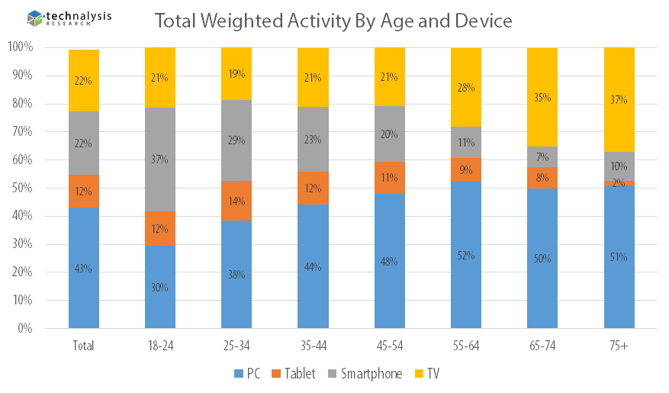
In addition to age-based considerations, the report uncovered important consumer usage metrics that will likely have a major impact on the devices people choose to purchase and use in the future. For example, consumers on average only spend 10.6% of their total smartphone time making audio phone calls, with younger users spending even less time talking and older users spending more. In addition, other popular activities on smartphones, including browsing the web and watching video, clearly lend themselves to larger screens, suggesting a strong interest in larger smartphones, such as the forthcoming iPhone 6.
Finally, the study offers a comprehensive look at each of 22 different activities, ranging from watching live TV programming, to browsing the web, listening to music, casual gaming and more, and how each of those activities are split across devices by age and country. For example, roughly 30% of overall live TV programming is now watched on a device other than a TV, but in China that number is 46%, and for the 25-34 age group across all four countries, it’s 38%.
“Consumers are clearly becoming accustomed to using a range of devices and are very willing to shift activities previously reserved for one device onto whatever devices they have access to,” says O’Donnell. “Moving forward, we believe this kind of usage behavior will have an important impact on both hardware products and the software and services on which they run.”
A copy of the complete report is available for purchase from TECHnalysis Research. For additional information, please e-mail the author at bob@technalysisresearch.com.
Founded by technology market research veteran Bob O’Donnell, TECHnalysis Research, LLC provides strategic consulting and market research services to the technology industry and professional financial community. Building on a deep understanding of critical technology and business trends, in conjunction with hard-hitting, original research, the firm provides unique "out-of-the-box" perspectives that are still grounded in the practical realities of the technology, media and telecom markets.

